True story in a land close-by (2020 Update)
AKA – How to sell and buy in this market with EASE

Seller Smith has their home on the market. They have an accepted contingency offer on Seller Brown’s house. Seller Brown is under contract to buy Seller Jones home… also, contingent.
THAT Seller is selling outright, not re-buying. End of domino line.

Buyer Evans makes an offer on Seller Smith’s home, however, when the “domino” is disclosed, as it absolutely should be, they balk.

Seller Smith does not want to sell to Buyer Evans if they are unable to buy Seller Brown’s home, however they offer to repay the Buyers’ appraisal and home inspection costs should they not complete their purchase, therefore allowing Buyer Evans to buy with no financial risk.

Buyer Evans says no.

Who loses this game?

Not Seller Smith. He has 4 more showings today because there are few on the market. [Buyer Evans offer was over list price and other Buyers were in back up. One of those Buyers is sure to accept his terms.] Seller Brown & Seller Jones won’t lose. Their dominos will fall as soon as Seller Smith gets a Buyer to accept the terms.

The loser in this scenario is Buyer Evans. They now need to go find another home to buy in a market that has little inventory. When Seller Smith’s sale posts (at over asking price) Buyer Evans will LIKELY pay even more for the next home… and may still have to accept a Seller Contingency with… perhaps… a Seller unwilling to pay them back for costs if they don’t sell.

Is this your current Real Estate world?

This has become the New Normal in many markets. Inventories remain at 30-year historic lows and this is causing different behavior in Buyers, Sellers, and Agents.

Agents that learn how to manage this market will also win this game, and in fact are likely to SOAR, while supporting their client’s dreams coming true.

Those that resist the change will, quite frankly, fail in a big way, missing an opportunity and worst of all, getting in the way of their clients’ needs.

Paraphrasing some famous quotes:

When the winds of change blow, some build a wall and others build a windmill.

When the winds of change blow, those that hide in in the ship’s cabin and very well may drown, yet those that put up the sail and adjust, go to lands they never dreamed of.

The attached article is for you to edit for your market (with your own stories or those from your office) and distribute a similar report to your Database of potential Sellers. Especially for those that want to Sell/Buy simultaneously.

Many people who own today are feeling they cannot find a home to buy, so are afraid to list. Fear paralyzes. They simply don’t know how to do it, and THIS is the reason we may see a sharp stall of the Real Estate market very soon. If we run out of inventory folks, some agents will go out of business. Don’t let it be you.

Sellers not knowing HOW is exactly the reason we are in this VERY low inventory market. We won’t get out of this until we have more listing inventory. Their lack of belief it can be done is our fault.

It’s OUR job to solve this

Mike and I were fortunate to live and succeed through this market before. We lived in Hawaii and inventory was so tight at times we had Buyers asking us to do things you wouldn’t dream of. Here are a few examples:

• Buyers giving us an escrow check to hold for a “future purchase” and signing a blank contract for us to fill out, at any price we believed would get them in 1st position. Just in case we couldn’t reach them when a home came on market that would work for them. It became less about the “right” home and more about getting ANY home.

• Buyers offering well over full asking price PLUS the agreement to buy a home at tens of thousands over appraisal, should it come in low. Mike and I personally bought our home with an offer to pay up to $15K over appraisal. This was STANDARD at the time in that market.

• Buyers making multiple over full price offers on 2,3,4 homes at once in hopes of securing one of them. In some cases, if they were able, buying SEVERAL properties, doing a little fixup or staging… and reselling. There were a few years that prices rose by over 2% per month.

• Buyers buying homes and waiving inspections or agreeing to do their own repairs for items found on inspections up to a limit. Sometimes tens of thousands of dollars.

• Buyers obtaining cash to buy outright and getting a loan after the purchase to pay back wherever they got the cash from. They sold stocks, liquidated retirement accounts, sold other properties, took home equity lines on other property, or borrowed it short term from wealthier relatives or friends. Just to be able to compete with other cash buyers.

When housing inventory is limited and Buyers have a need to buy, you’d be surprised at what Buyers are willing to do… IF we get out of the way and let them buy. Is any of this illegal? No - Not if agreed upon in writing and disclosed as required.

While most of us are not here yet, we are getting there in some markets. And other markets are soon to follow.

This is what high demand and super low inventory looks like. You need to be charting the new inventory each month in your area and price ranges… and the # of new pendings each month, so you have a handle on what’s happening.

If this happens in your area, you need to properly advise both your Seller and your Buyer clients.

Knowing how you can help the Sellers and Buyers you represent is critical in your success.

Ready to build a windmill and generate energy?

Ready to adjust your sails and SOAR?

Awesome. You will win this game.

And more importantly, your Clients will.

Article for your Database and Leads follows.
Please copy, paste and edit for your market.

How to Sell your house today…
AND Buy another one in this market

Feeling stuck in your home? You are not alone. Many Sellers want to sell in this market, but don’t know where to move to, or even if they CAN find a replacement property. They may have even heard stories of owners forced to move out of their homes when they couldn’t find a replacement property.

Why does it seem like there are almost no homes for sale for you to buy IF you did sell? Because it doesn’t just seem that way. Inventory is record breaking low in many markets*.

This article will help you understand the facts about our market and how we got here. And more importantly, what you can do as a Seller to WIN in this market selling and WIN again in Buying.

Yes, it IS possible with the right advice.

Having an Agent represent you who understands this is CRITICAL now more than ever before. Choose an agent that can explain these strategies in detail and help YOU choose the right options for your situation. It is not the market to gamble with just any Agent.

___________________________________________________

*Inventory of homes for sale is at historic lows. Nationally we are at 30+ year lows. Many areas have less than 30 days of remaining inventory on the market, causing prices to go up, sometimes dramatically.

Nationally that number is right around 3.5 weeks for a median priced home. This means that at the current pace of sales, if no other properties listed from today out, we’d sell every single home on the market now in the U.S. in less than 4 weeks.

Those that don’t sell also gain that equity as prices rise. So… what’s the rush in selling you might ask? I’ll get to that in my postscript**.

Let’s look at the Why this happened first, and then we will get to several solution options. At least one WILL likely fit your needs.

Why are there few homes for sale?

Several factors are at play.

Reason #1

Construction of new homes did not keep up pace with population growth during the housing recession of about 2008-2014. When builders did start the processes to build again over the last few years, in many areas that process takes 3-7 years to get to the point of having actual homes for sale. New homes are up and running now but can’t keep up with demand.

Worse yet, so many builders went out of business in those bad years, moving on to other careers, it’s quite possible there simply aren’t enough of them to keep up with demand even if permit times were shorter. They also are more cautious and realize we have had an up market a LONG time right now.

Many agents have lots for sale that they cannot find a single builder willing to commit to building on. In addition, the labor market is tight… people can get other jobs that pay better than manual labor that keeps them below the poverty line. The U.S. also does not intend to immigrate more working class into the country soon.

This means new home prices will continue to go up as we struggle to find people to build them. Every builder I know is having trouble finding enough workers.

Reason #2

People are staying in homes longer than ever. See chart below.

While I can’t find a graph for our current year, I did see that in 2018 that average SHOT UP to 13 years!
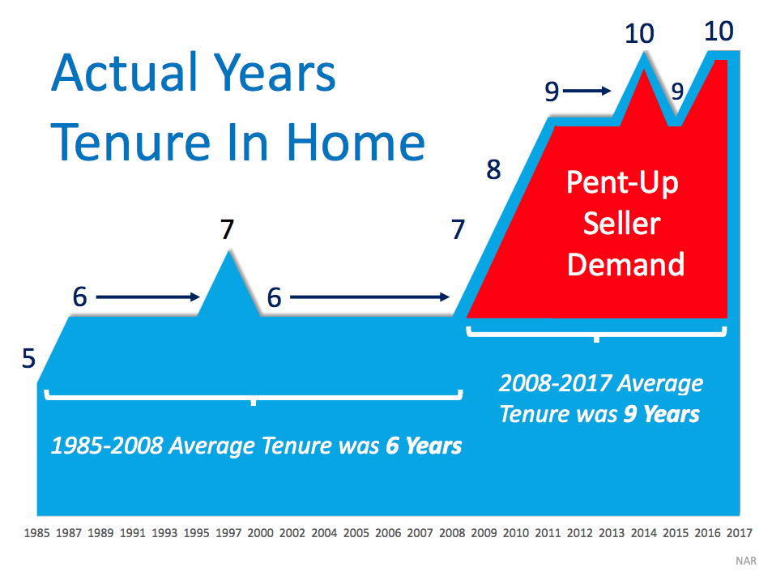
Part of this was from necessity. No equity and/or bad credit = No move.

Many people slowly, and mostly with cash, remodeled houses to work better for them over the last 10 years, rather than sell and re-buy one that suited their changing needs. For many, this created additional equity in smart improvements.

Part of the staying longer is also due to ultra-low interest rates. A lot of people have fixed rates of 2.5-3.5% that they just can’t find it in their hearts to give up. Don’t get me wrong, rates are still great.

30 Year Fixed Mortgage Rates are about 3.5% as of this writing (August 2020) compared to a historic average about 8.5%.

Some owners are moving but keeping their homes with low interest rates as rentals, since the tenant’s rent pays off the property and they are building additional equity to be used for retirement wealth building. Notice that those homes are NOT coming on the market for sale.

If you are staying put longer than 6 years,
please reply with your personal reason “why”
for a survey I am conducting.

Reason 3

Fear. Many owners have a fear of buying another home and giving up their great equity position due to the last turndown of the market. What if it happens again? What if they sell their nice safe investment and get a big new mortgage and it all goes to heck again. This is highly unlikely. See postscript.**

Let’s move on and look at SOLUTIONS!

How DO I find a replacement property in this Market?
So, I CAN sell my house!

What if I sell and can’t find one to buy?

Start with this question: Do you WANT to move? Get clear on that first. Are you happy in your current home? Is it working for you now… and more importantly, will it be working for you for the next cycle of the market which is normally 7-11 years?

If your answer is YES, then hey, stay put if you want to! The good news is moving IS optional. If the market does keep going up… or goes down, won’t matter to you, right?

But if the answer is NO… If your home is NOT the one you want to be in for the next 7-11 years, then we need to talk. Because if the fear of something “bad” happening is keeping you from being happy, there are solutions. Do you know all of the options you have?

Finding out doesn’t mean deciding, it simply makes you become aware of the possibilities. And one thing I believe is that everyone should know what options they have, so they can choose their best personal option. Hiding our heads in the sand is an option too, but why would anyone choose that?

Here are SOME of the many options in today’s market:

- Stay in your home, the way it is, or remodel it with cash or an equity line of credit or refinance.

- If you have the cash and qualifications to do so, buy a new home before you sell this one. THEN sell this home. If the market continues to go up in value, THIS is a great option because you hold the control on both ends of the transaction. You are under no pressure to sell so you can buy… and under no pressure to buy, so you can sell. Best negotiating position of all as a Buyer!

- Buy a replacement property with the equity in your home, even before you sell. This works great if you have a lot of equity and are buying down, and/or have a Seller side willing to hold a portion of mortgage for you, even temporarily.

- List your home and sell it for top dollar… and move into a temporary home until you find a replacement property. Did you know that most professional movers will store your belongings for MONTHS while you find a replacement property? This also puts you in a position of strength with less pressure on both ends of the transaction.

- List your home for sell with a contingency that if you do not find a replacement property, you are under no obligation to sell. Yes, this is possible. Then shop while your home is on the market. You may be able to price a bit higher until you find a replacement property to test the upper end of the market and if it doesn’t sell, reduce when you go under contract on a purchase.

- List your home for sale and negotiate a rent-back of your own home while you find a replacement property. Yes, this is possible in many markets.

- Find a replacement property that will allow you to move into early and pay rent to the owner until closing. You’ll complete the purchase when your home is sold & closed, at which time you buy the replacement home you are already living in. Yes, this too is possible though harder in this market.

- Sell your home and move into your 2nd home or rental property. I’ve seen some Sellers do this long enough (usually about 2 tax returns) to cause property 2 to become a primary residence, in which case they can sell that property and not owe capital gains. Selling these properties without this step (and without conducting a 1031 Exchange) would normally cause a taxable event. This option can save that taxable event from ever occurring, as primary residences are gain-exempt up to $250K for a single or $500K if you’re married.

Note: Consult your tax advisor about your property’s current tax status and how any of the ideas above may affect you.

The opportunity to be in the RIGHT home for you is possible… if you will take advantage of the opportunity. Set an appointment with us to discuss YOUR best solution options.

The bottom line is that you have options today that may not be there in the future. In fact, we may even come up with one unique to YOU that is not even listed above! Let’s meet.

Mike and Donna Stott, Realtor, CRS
Northwest Atlanta Properties
ICF ACC Accredited Coaches
Your Coaching Matters

**P.S. Here are the promised I’ll-get-to-those-related-questions in the article above.

**Why should you not be concerned about the market crashing again?

- We may not yet have peaked. Demand is VERY high right now for several reasons listed below. Until we reach a balanced market (about 6 months of remaining inventory) and then fall into more than that, prices are going to keep rising. It’s simply supply and demand. Now…. why we have not peaked:

- Pent up demand from former homeowners who have been unable to buy due to short sales or foreclosures in the down cycle. These people believe in home ownership and now that their bankruptcy, foreclosure or short sale is far enough off their credit, they are buying again.

- Pent up demand from people who have been waiting to buy and can’t wait any longer.

- Consumer confidence is VERY high. Despite unsettling times, consumers have not been this confident about buying homes at any time in the recent past. They also are working from home more and need the space and the security they will not be forced to move.

- Millennials may not be buying…yet. But they will. Many potential buyers in their 20’s and 30’s have not purchased a 1st home even though the median age of a 1st time buyer is now 28 years old. They married later and have kids later or not at all. My belief is that they see their parents financially succeed by remaining or becoming homeowners they will see no way for themselves to enjoy that success without buying. As they DO have kids, this is a massive generation that will be buying.

- Interest rates are unbelievable.

- Rates are still near historic lows (see chart below) and until and unless they rise dramatically - which is not predicted by anyone I can find - housing will remain VERY affordable.

- In most cases, these rates cause total home payments to be FAR more affordable than renting.

- Should I be wrong and the market crash, your 30 or 15- year fixed rate causes your monthly payment to remain SUPER affordable EVEN if we have a down cycle to get through.

EVEN if you became upside down again, which is highly unlikely.
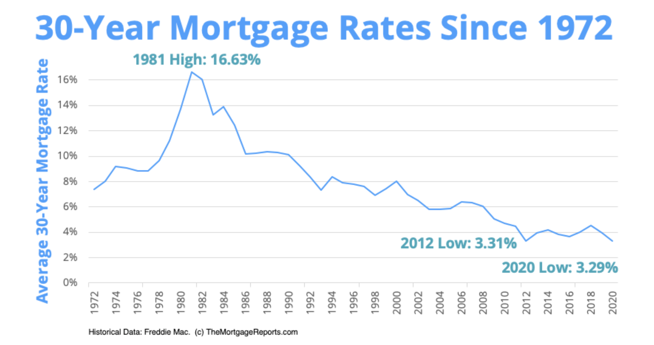

**Why should you consider doing this NOW, even if you don’t have to.

- You should be happy in your home. As a Realtor, my firm belief is every person should be in a home that works for them now and for the foreseeable future. If you aren’t 100% happy, and we have a solution that works for YOU, then you should take it.

- If you have fears… such as the market crashing or interest rates rising than for goodness sakes, you are going to get “stuck” somewhere. You might as well get STUCK in the home that works both now and for the next real estate cycle.

- For many homeowners, their current home has some deferred remodeling or maintenance they will have to deal with in the next few years. In this hot market, many buyers will accept these things, whereas when we get to a more balance market or worse, a declining one, they will not. For a lot of you, your current home will make a great 1st time buy. And you get a better, more expensive nicer one which are more available than 1st time buyer type homes. Win-Win for you.

- Buying a new or newer replacement property now could cause any maintenance or remodeling to be out of YOUR hands for another 5-15 years. For many of us that solves a lot of problems. No replacing a roof in a few years, no remolding our kitchens and bathrooms. Boy…. Is THIS an opportunity.

- Let’s go back to Interest Rates again. Historically getting a rate below 4% on the home for your next 5-10-20 years is a gift from the heavens. What if rates go up? Then YOU win because you did it while they were still low. What if rates go down? Simply refinance. You still win.

For these reasons and more you may want to get into the RIGHT home NOW. Because no matter what, you win.

